Infrastructure and Endangered Species
Now it is more crucial than ever to prioritize environmental protection and conservation efforts; it is a matter of national security, economic security, and even human health. Climate change, habitat destruction, and the Earth’s sixth mass extinction event threaten wildlife, ecosystems, and the very fabric of this planet we call home. As Congress moves to address our aging infrastructure, we have an unparalleled opportunity to invest in environmental safeguards and conservation innovations that will ensure American wellbeing and security, and create jobs and prosperity for the citizens of today and for many future generations.
Protect ESA and NEPA reviews in any construction
The Endangered Species Act (ESA) and the National Environmental Policy Act (NEPA) are essential for ensuring the continued health and wellbeing of vital ecosystems. NEPA and ESA analyses protect against substantial social, environmental, and economic harm. For instance, a highway or train tracks may displace entire neighborhoods, degrade wetlands and rivers, destroy wildlife habitat, and produce air pollution and disruptive noise. These reviews allow construction projects to move forward while ensuring full disclosure of potentially harmful outcomes, informed decision-making, and risk mitigation.
- Any infrastructure investment plans must include robust compliance and support for these bedrock conservation laws and exclude waivers.
Increase infrastructure resiliency and longevity
Smart infrastructure investments save money, improve the durability and functional longevity of infrastructure and minimize adverse environmental impacts through careful planning, siting, construction and operation of roads, bridges and other “gray” infrastructure investments.
- Invest in clean, renewable energy generation and incentivize construction of projects that avoid conflicts with wildlife and habitats.
- Site transmission infrastructure improvements to reduce conflicts and unnecessary impacts to resources and communities.
- Support resiliency and adaptation to extreme events through updated design standards, and avoid projects that perpetuate or worsen drought, fire erosion, flooding, wildlife habitat loss and fragmentation and other negative social and ecological impacts.
- Improve existing infrastructure using environmentally responsible, durable and sustainable materials to ensure usability into the future.
A single acre of wetlands can hold up to 1.5 million gallons of rain or melting snow
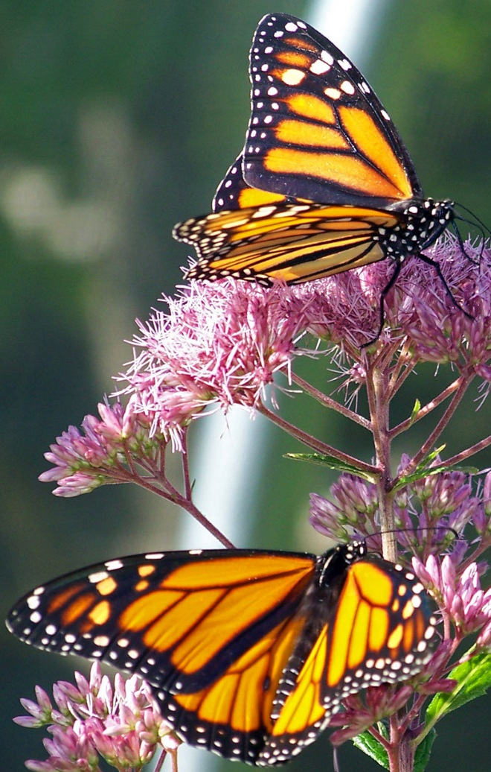
Plant native flora
The use of native plants can save taxpayers money and produce huge benefits for agriculture and public health by supporting natural pollination, pest control, and water quality improvement at local and regional scales. Non-native plantings come with two risks: they can fail, requiring replanting, or they can succeed too well and become invasive, requiring expensive control down the line. Native plants that are adapted to local conditions are more likely to survive, preventing the need for re-planting and saving taxpayer money.
- Fund the National Seed Strategy, a coordinated federal effort to collect, catalog and store seeds from native plants to ensure that restoration efforts (such as after a fire or flood) have a ready source of appropriate plant materials.
- Incentivize communities and landowners and mandate federal land managers and other agencies to use native plant landscaping.
- Encourage pollinator gardens, stormwater gardens and roadside plantings, installation of bat boxes, and better management of lawn and garden inputs.
- Ensure that disaster response and restoration work uses native plants where feasible.
Native plantings support natural pollinators

Create resilient and sustainable Water and Waste Management systems
The American Society of Civil Engineers gives America’s crumbling and outdated wastewater infrastructure a “D-” grade overall. Sewage and combined overflow are detrimental to lakes, rivers, and oceans and may have serious adverse impacts on marine species. Plastics and other debris in waterways also cause significant harm. When stormwater is managed as a waste product, it has serious implications, including flooding, changed river flow, and environmental contamination from runoff and sewage overflow. “Green infrastructure” solutions for natural stormwater management leverage the power of ecosystem services to more sustainably and effectively manage stormwater.
- Implement natural alternatives to gray infrastructure, including wetlands and dune restoration, reducing long-term maintenance costs and enhancing environmental benefits. Use soil and vegetation in a constructed technique, such as rain gardens or green roofs, to mimic natural hydrologic processes like percolation through soil and plant uptake and transpiration.
- A single acre of wetlands can hold up to 1.5 million gallons of rain or melting snow. For less than $300,000, it’s possible to construct an artificial wetland that can intercept 3.25 million gallons of stormwater otherwise destined for the sewer.
- Preserve natural features, such as floodplains with a natural vegetation buffer along streams that can slow, filter, and store polluted runoff. A single mature tree with a thirty-foot crown can keep 4,600 gallons of water out of the sewer each year.
- Minimize or disconnect impervious surfaces (such as pavement), using methods such as rain barrels, narrower streets, and permeable paving.

Reinvigorate Public Land investment
Natural areas on public lands provide numerous valuable ecosystem services to the American people including clean water and water purification, filtration, and storage; flood control; soil stabilization; climate regulation; wildlife habitat and corridors; and recreation opportunities. Unfortunately, some of these natural areas require restoration and habitat improvement, and existing infrastructure may threaten ecosystem services, especially if in a degraded condition. For example, national forests contain more than 380,000 miles of roads (more than seven times as many miles as the interstate highway system), some 7,000 bridges and over 1,700 dams. Efforts must be made to repair or in some cases remove infrastructure that poses a threat to ecosystem and public interest values.
- Conserve, restore, and improve public lands’ ability to provide vital ecosystem services.
- Enhance policy and funding to restore degraded watersheds and enhance the climate and fire resilience of ecosystems.
- Create science-based land management and climate adaptation plans for both green and gray infrastructure as well as construction, maintenance and restoration projects at the four Federal land management agencies – the National Parks Service, the U.S. Forest Service, the Bureau of Land Management, and the U.S. Fish and Wildlife Service.
- Protect more lands from development and expand our public lands to support long-term resiliency in the face of changing climate and other pressures.
- Ensure that projects are designed, located, and constructed so as not to impede ecosystem function, and to be resilient to future conditions, including sea-level rise and higher storm ratings, based on the best available science.
- Repair, retrofit and replace culverts on forest roads to improve water flow and reduce flood damage in extreme precipitation events.
- Cap open marker pipes on BLM lands to prevent countless needless bird deaths.
reduce wildlife conflicts with Wildlife Corridors and crossings
Our surface and water transit routes are important to the American way of life, but they also represent physical barriers that can be insurmountable for wildlife and dangerous for everyone. Wildlife collisions cause harm to animal species and humans in what are known as wildlife-vehicle collisions (WVCs). Every year in the U.S. there are an estimated 1-2 million collisions that occur between motorists and large animals. These collisions result in 200 human deaths and more than 26,000 injuries, at a cost to Americans of more than $8 billion annually. A 2011 study by the insurance industry estimated that over $1 billion dollars per year is spent on property damage due to WVCs while the total annual cost to American taxpayers is nearly $8.4 billion. In addition, walls, fences, roads, and dams impede migratory routes, cut off food and water supplies, and otherwise disrupt important wildlife habitats. We can and must improve safety and safeguard biodiversity and ecosystem health by creating and protecting habitat connectivity, wildlife corridors, and crossings for wildlife.
- Establish or maintain wildlife corridors, which provide habitat or ecological connectivity, and allow for fish, wildlife, or plant movement.
- Install structural elements like underpasses, culverts, overpasses, animal detection systems, or crosswalks to allow wildlife to avoid road traffic. Adding wildlife crossings can effectively save the nation billions of dollars as well as human and animal lives,,.
Endangered Idaho Ground Squirrel
- Remove obsolete fencing, and upgrade and mark extant fencing to improve connectivity for migratory game and other species, while also reducing collision mortality of grouse and entanglement of other wildlife.

Kevin DeGood, “Build First, Ask Questions Later: How Weakening Environmental Review Will Hurt Our Communities and Natural Habitats” (Washington: Center for American Progress, 2017), available at https://cdn.americanprogress.org/content/uploads/2017/05/02070904/DeGood-BuildFirst-brief.pdf; Kristina Costa, Lia Cattaneo, and Danielle Schultz, “When Communities Didn’t Have a Say: How Federal Infrastructure Dollars Were Used to Bulldoze Communities of Color” (Washington: Center for American Progress, 2018), available at https://cdn.americanprogress.org/content/uploads/2018/04/23082638/CostaEnvironmentalReview-brief-1.pdf.
An analysis of 88,290 Section 7 ESA consultations recorded by the U.S. Fish and Wildlife Service (FWS) from 2008 to 2015 found that no project was stopped or extensively altered as a result of FWS finding jeopardy or adverse modification. https://home.cci-dev.org/section-7-pnas/
https://www.blm.gov/programs/natural-resources/native-plant-communities/national-seed-strategy
There are 600,000 miles of sewer pipes across the country and the average age is 33 years. Some pipes in cities along the eastern seaboard are nearly 200 years old. Some are even made of wood. https://www.infrastructurereportcard.org/making-the-grade/
https://www.americanrivers.org/rivers/discover-your-river/10-facts-about-flooding/
https://www.americanrivers.org/threats-solutions/clean-water/sewage-pollution/
https://www.americanrivers.org/threats-solutions/clean-water/green-infrastructure/
According to USDA that is an estimated 380,000 miles of Forest Service roads not including public roads such a state, county and private roads maintained by others on National Forest System. https://www.fs.fed.us/eng/road_mgt/factsheet.shtml last observed 1/24/19
According to the Federal Highway Administration: Currently, the Interstate System is 46,876 miles long https://www.fhwa.dot.gov/interstate/faq.cfm#question3
https://www.fs.fed.us/eng/road_mgt/factsheet.shtml
https://www.fws.gov/cno/conservation/MigratoryBirds/DeathByPipes-final.pdf
Huijser, M.P., P. McGowen, J. Fuller, A. Hardy, A. Kociolek, A.P. Clevenger, D. Smith and R. Ament. 2008. Wildlife-vehicle collision reduction study. Report to Congress. U.S. Department of Transportation, Federal Highway Administration, Washington D.C., USA.
Id.
Putting a Dent in the Cost of Wildlife-Vehicle Collisions, Defenders of Wildlife Blog, September 20, 2011, https://defendersblog.org/2011/09/putting-a-dent-in-the-cost-of-wildlife-vehicle-collisions/
Putting a Dent in the Cost of Wildlife-Vehicle Collisions, Defenders of Wildlife Blog, September 20, 2011, https://defendersblog.org/2011/09/putting-a-dent-in-the-cost-of-wildlife-vehicle-collisions/
In Idaho, vehicles were responsible for the death of 159 deer, about seven per year from 1979 to 2001. Following the introduction of a wildlife corridor, the number of deer killed in that area during the subsequent migration season dropped to nearly zero. Katy Moeller, Idaho 21 Wildlife Underpass Apparently Works, ARC, May 30, 2012, https://arc-solutions.org/article/idaho-21-wildlife-underpass-apparently-works/
In Maine, only one WVC on the Gorham Bypass was documented between 2008 and 2011 compared to the 12 WVCs documented on the adjacent Route 114 where wildlife passages had not been introduced. Wildlife Crossings Protect Wildlife Along Maine’s Route 112, Federal Highway Administration, December 2012, https://arc-solutions.org/wp-content/uploads/2013/02/FHWA-Successes-WCs-in-Maine.pdf
http://www.sagegrouseinitiative.com/wp-content/uploads/2014/03/Science-to-Solutions-Fence-Collisions-032114-1.pdf

