May 21, 2020
Jonathan Paklaian
Grand Staircase Escalante Partners
Conservation Programs Manager

Attached to this document is a summary of job metrics from the Escalante River restoration from last five years (2015-2019). There will be a tab for each year. You’ll see the breakdown that includes the number of people working and the length of their time here. It varies, but is usually around two months. There are also some other interesting metrics such as at-risk & underserved workers.

We have a strong framework from the past ten years and a robust partnership that helped accomplish this work. It was almost entirely Russian olive removal. This framework can be applied to a number of other restoration projects from other woody invasive removal (tamarisk), secondary weed removal, planting and seeding, trail work and rehabilitation, etc. This project has created jobs not just with conservation corps workers, but provided work for horsepackers, aerial seeding flights, machine operators, and wildlife surveys.

If you visit the Escalante River Watershed Partnership website (link below), you’ll find a list of partners and detail on the projects, as well as promotional videos. We were expecting one more video this year to highlight the finishing of initial Russian olive treatments at the end of 2019, but it has experienced delays. We hope to have the final version soon.

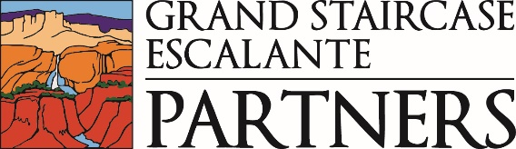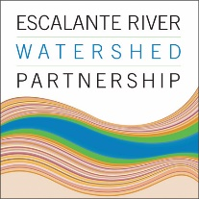

https://gsenm.org/
http://escalanteriverwatershedpartnership.org/

