Summary
The House should include the bi-partisan Wildlife Corridors Conservation Act, H.R. 2795, and the bi-partisan wildlife crossing pilot program and related provisions expanding wildlife infrastructure funding eligibility found in S.2302, in its transportation stimulus plan. These proposals would create smart infrastructure with significant economic returns and help create more climate resilient landscapes that protect people and wildlife.
Reported collisions between motorists and wildlife cause more than 200 human fatalities and over 26,000 injuries each year, at an annual cost to Americans of more than $8 billion. In addition to the human toll, an estimated 1-2 million large animals are killed by motorists every year. Numerous research studies show that wildlife crossing structures that guide animals over or under our nation’s highways are highly effective, reducing wildlife vehicle collisions by up to 97%.
In addition, wildlife corridor protection and crossing construction as found in H.R. 2795 and S. 2302 support more resilient landscapes by allowing wildlife to move, particularly in the face of climate change. Actively protecting more biodiverse landscapes by safeguarding corridors and constructing crossings will create jobs while stemming species loss and extinction.
Chair of the Transportation and Infrastructure Committee, Peter DeFazio stated on April 1, 2020, “we’ve got to rebuild our infrastructure, let’s rebuild it in a way that is resilient for severe climate events.” … “If you’ve got to rebuild it, rebuild it the right way.” Wildlife corridor protection and crossing construction are the right way to rebuild America’s roads and protect people and wildlife.
Jobs and economic stimulus
High return on investment
Sustained infrastructure spending can produce economy-wide returns of close to $3 per every $1 invested over a 10 to 15-year recovery period—when considering broadscale efficiency and productivity. Wildlife infrastructure projects like animal road crossings have the same benefits. Huijser et al. (2009) found that structural highway mitigation measures for wildlife had positive cost-benefit values when installed on roadway segments with as few as 5 motorist crashes involving deer per mile per year. The numbers were even lower for crashes involving larger animals such as elk (~2 crashes/mile/year) and moose (~1 crash/mile/year). Notably, costlier projects like underpasses and overpasses with associated infrastructure such as fencing (that guides or “funnels” animals to crossing structures) and “jump outs” (ramps that allow animals trapped on the highway to exit) produced the highest returns on investment.

Example: The State of Nevada recently assessed the effectiveness of its wildlife crossings. Dedicated wildlife crossings drastically reduced mule deer deaths and vehicle accidents. Its large overpass built in 2010—while the costliest mitigation measure—produced near universal safe crossings. As the table below shows, the net positive worth of the project was nearly $4,000,000 and the benefit-cost ratio was nearly 1.6. The State concluded that well designed crossings like its overpass had significant “economic justification.”
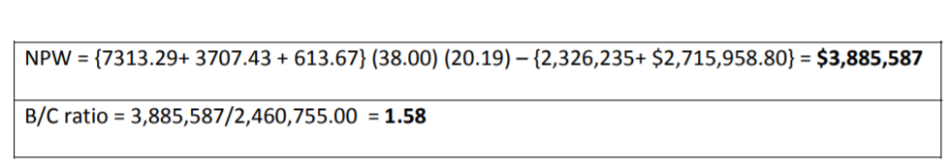
Quick investment recapitalization
While having high returns on investment, wildlife crossings and related infrastructure have also been shown to very quickly pay for themselves. Example: The State of Colorado recently installed “jump out ramps” on HWY 550 to mitigate deer and elk fatalities. In addition to nearly eliminating collisions, the project was also an incredible economic success. The State found the “cost recovery timeframe for [project] construction was 1.35 to 2.20 years.”
Direct assistance for landowners
Wildlife corridors lead to significant returns on government investment, but they will also directly aid private landowners. H.R. 2795, the Wildlife Corridors Conservation Act, included a provision creating the Wildlife Movements Grant Program. The new grant program would distribute $50,000,000 annually for wildlife movement projects. Voluntary landowners are eligible recipients of the grants under § 301(c)(1) of the bill. This provision would inject millions of dollars directly into taxpayers’ pockets; moreover, the program will likely target rural communities and large landowners like farmers and ranchers—all of whom are priorities under stimulus programs.
More industries, workers, and sectors of the economy
The engineering complexity of wildlife-specific infrastructure suggests more diverse and widespread direct capital benefits than found for conventional roadbuilding. Normal infrastructure projects like road building have a narrow set of beneficiaries as shown in the CEA figure below. Roadbuilding inputs for many traditional projects are limited to paving equipment, cement, gravel, and asphalt and construction personnel. As the table below shows, crossing infrastructure would also use metals, timber, earth, steel, wiring, and vegetation. It would require additional professional engineering, design, surveying, and biological evaluation and inputs. Since S.2302 will continue the Buy America requirements to source goods under the FAST Act, its provisions are guaranteed to direct stimulus to American companies. These projects would provide bigger pieces of the pie to industries and workers that are too often left out during traditional road building.
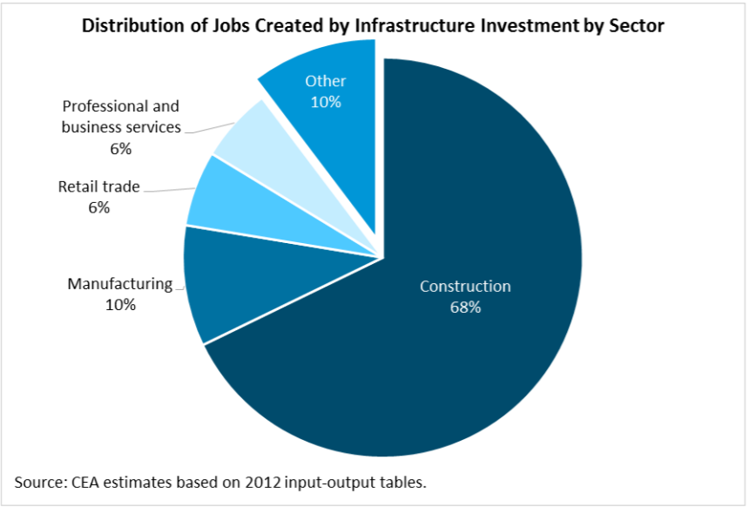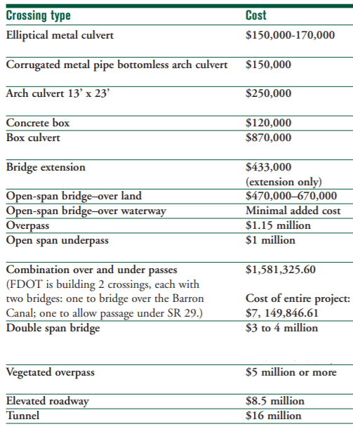
Logical connection to other roadbuilding
Constructing crossings is less costly when done concurrently with other infrastructure projects, given basic economies of scale and scope. More importantly, new roads, wider roads, and increased traffic often lead to more vehicle collisions that endanger human safety and increase wildlife mortality. By pairing traditional highway projects with wildlife crossings, those effects are diminished. Because the transportation stimulus will likely lead to thousands of new roadbuilding projects, it makes economic and biological sense to increase investment in wildlife mitigation measures at the same time to reduce the environmental and social impacts.
Example: The State of Montana widened HWY 93 by adding two lanes last decade. Where the highway was rebuilt without mitigation measures, the change in configuration and increase in traffic volume lead to increased wildlife-vehicle collisions. However, in areas where the state worked with the Confederated Salish & Kootenai Tribes and public interest groups to install mitigation measures with fencing, wildlife-vehicle crashes were reduced by 70-80%.
Benefits to diverse populations
Reaching at-risk areas
Wildlife corridors and crossings would create jobs and stimulate economies in rural, historically impoverished areas and in parts of the country where other stimulus programs have less application. Example: The table below lists 3 wildlife infrastructure projects proposed for the New Mexico Wildlife Corridors Action Plan. These potential sites are in rural areas with surrounding communities with per capita income well below the national average.
Proposed corridor project location | Pop density (per sq. mi) | Per capita income | % minority
I-10 near Peloncillo Mountain | 3 | 20,796 | 47%
I-25 north of Placitas, New Mexico | 139 | 26,869 | 62%
Rio Grande National Monument near Cerro, New Mexico | 53 | 23,178 | 69%

Assistance to Native Tribes
The Wildlife Corridors Conservation Act and the Senate’s wildlife crossings pilot program and related provisions that expand funding eligibility for wildlife infrastructure would directly benefit native tribes through financial grants. Title II of H.R. 2795 is dedicated to providing technical, administrative, and financial assistance for corridor creation and management; tribes are also eligible recipients under the § 301 Wildlife Movements Grant Program of the bill. The pilot program likewise lists Indian tribes as potential beneficiaries of grants. It has been noted that native tribes have been left out of much of the stimulus talks so far; these provisions could lead to millions of additional dollars of much-needed stimulus funds flowing to tribes. Finally, multiple tribes have existing crossing projects or have supported the legislative proposals to invest in tribal corridors and wildlife infrastructure.
Federal Funding for Wildlife Crossings and Corridor Protection provides needed support for states
In 2019-2020, 11 States introduced and 5 states passed wildlife corridor protection legislation, including New Hampshire, Oregon, New Mexico, Utah and Virginia. Although states are initiating wildlife corridor and crossing protection, funding to implement these efforts is sorely needed. In addition, all 11 states covered by the U.S. Department of Interior Secretarial Order 3362, Improving Habitat Quality in Western Big-Game Winter Range and Migration Corridors, reported that roads were an impediment to the migration and movement of iconic western big game species such as elk, pronghorn, and mule deer. Public support is also strong, with more than 84% of respondents in Colorado and New Mexico saying they would like to see increased efforts to safeguard wildlife corridors, and 87% expressing support for building more overpasses and underpasses for wildlife.
Protecting wildlife across the United States supports jobs in outdoor recreation and hunting and fishing
Direct economic impacts from various wildlife-related industries are important to overall national GDP and especially important to many rapidly diversifying rural economies across the country. Estimates place the economic contribution of outdoor recreation at $427.2 billion per year (or 2.2 percent of GDP), including hunting and angling at over $200 billion per year and bird watching at $41 billion per year. Protecting wildlife corridors and crossings are a vital strategy for protecting game species such as mule deer, pronghorn and elk.

Cost savings, value added, and public health
$8 billion per year lost to Wildlife-Vehicle Collisions
More than $8 billion are lost annually due to wildlife-vehicle collisions, including vehicle damage, repair, medical treatment, and other costs. Crossings and corridors would help reduce these rates, lightening a major strain on local economies and individual taxpayers, especially those in rural communities, given that 89% of crashes involving wildlife occur on 2-lane roads.
Reducing serious injuries and strain on emergency healthcare
In addition to the staggering economic loss associated with wildlife-vehicle collisions, these accidents cause over 26,000 injuries per year. In a time when hospitals and emergency medical services are overburdened, we should invest in infrastructure that will indirectly reduce the strain on the healthcare industries.
Additional economic benefits
Wildlife crossings and corridors can produce myriad long-term economic benefits. The Natural Resources Conservation Service (NRCS) of the USDA recently examined the environmental services and economic values associated with wildlife corridors. Corridors were found to (1) increase crop yields and crop quality, (2) increase livestock production and improve livestock health, (3) reduce energy consumption, (4) increase property values, and (5) increase recreation revenues.

Conclusion
The provisions within the Wildlife Corridors Conservation Act and the Senate’s wildlife crossing pilot program and related provisions expanding funding eligibilty for wildlife infrastructure would lead to high returns on investment that quickly recapitalize and reach a broader segment of the country and economy than other stimulus proposals. They will lead to longterm economic and environmental benefits well worth inclusion in the next phase of stimulus.

Jeffrey Werling and Ronald Horst, “Catching up: greater focus needed to achieve a more competitive infrastructure” (2014) at p. 9
See generally Marcel P. Huijser et al., “Cost-Benefit Analyses of Mitigation Measures Aimed at Reducing Collisions with Large Ungulates in the United States and Canada,” 14(2) Ecology and Society 1 (2009).
Nevada Dep’t of Transp., “Effectiveness of Wildlife Crossing Structures to Minimize Traffic Collisions with Mule Deer and Other Wildlife in Nevada” (2015) at p. 20.
Jeremy Siemers, Colorado Dep’t of Transp., “Monitoring Wildlife-Vehicle Collisions: Analysis and Cost-Benefit of Escape Ramps for Deer and Elk on Highway 550” (2015) at p. 29.
National Economic Council and the President’s Council of Economic Advisers, “An Economic Analysis of Transportation Infrastructure” (2014) at p. 8.
Defenders of Wildlife, “Getting up to speed: a conservationist’s guide to wildlife and highways” (2007) at p. 154.
Federal Transit Administration, “FAST ACT: Overview” (https://www.transit.dot.gov/FAST).
Huijser et al., “U.S. 93 North Post-Construction Wildlife-Vehicle Collision and Wildlife Crossing Monitoring on the Flathead Indian Reservation between Evaro and Polson, Montana” (2016). [https://www.mdt.mt.gov/other/webdata/external/research/docs/research_proj/wildlife_crossing/phaseii/PHASE_II_FINAL_REPORT.pdf]
See EPA, EJ Screen (using 5-mile buffer) and American Community Survey dataset. [https://ejscreen.epa.gov/mapper/]
National Wildlife Federation, “Overwhelming Public Support for Protecting Wildlife Migration Routes” [https://www.nwf.org/Latest-News/Press-Releases/2019/04-22-19-Wildlife-Migration-Poll]
U.S. Department of Commerce, “Outdoor Recreation Satellite Account, U.S. and Prototype for States, 2017” (2019) [https://www.bea.gov/system/files/2019-09/orsa0919_1.pdf]
See National Shooting Sports Foundation, “Hunting in America: An Economic Force for Conservation” at p. 5; American Sportfishing Association, “Sportfishing in America: An Economic Force for Conservation” at p. 4.
U.S. Fish and Wildlife Service, “Birding in the United States: a demographic and economic analysis”
Marcel Huijser et al., Western Transportation Institute, “A Wildlife-vehicle collision reduction study: Report to Congress” (2008) at p. 232.
Id. at p. 38.
Natural Resources Conservation Service, “Corridors Benefits” at 4-11.

